Modern Beatitudes
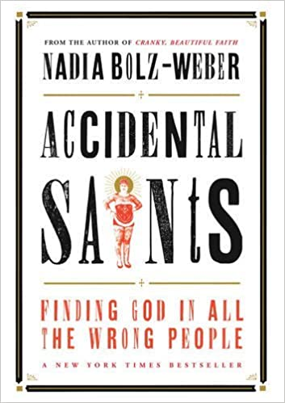

All Saints Sunday, is a time when we remember
and celebrate the lives of those who have gone before us,
who Jesus would bless.
I thought maybe it was time to have some beatitudes
for this time of pandemic, for this place, and these people,
remembering those who have succumbed to COVID-19
and those grieving the loss of loved ones, left to pick up the pieces,
because I like to imagine Jesus here standing among us saying:

Blessed are the poor in spirit, for theirs is the kingdom of heaven.

Blessed are the agnostics. Blessed are they who doubt. Those who aren’t sure, who can still be surprised. Blessed are they who are spiritually impoverished and therefore not so certain about everything that they no longer take in new information.

Blessed are those who have nothing to offer. Blessed are they for whom nothing seems to be working. Blessed are the pre-schoolers who cut in line at communion. Blessed are the poor in spirit. You are of heaven and Jesus blesses you.

Blessed are those who mourn, for they will be comforted. Blessed are they for whom death is not an abstraction. Blessed are they who have buried their loved ones, for whom tears are as real as an ocean. Blessed are they who have loved enough to know what loss feels like. Blessed are the mothers of the miscarried. Blessed are they who don’t have the luxury of taking things for granted any more. Blessed are they who can’t fall apart because they have to keep it together for everyone else. Blessed are the motherless, the alone, the ones from whom so much has been taken. Blessed are those who “still aren’t over it yet” Blessed are they who laughed again when for so long they thought they never would. Blessed are those who mourn. You are of heaven and Jesus blesses you.

“Blessed are the meek, for they will inherit the earth. Blessed are those who no one else notices. The kids who sit alone at middle-school lunch tables. The surgeons, doctors, nurses and laundry guys of our NHS. The sex-workers, night shift street sweepers and delivery drivers. Blessed are the losers and the babies and the parts of ourselves that are so small, that don’t want to make eye contact with a world that only loves the winners. Blessed are the forgotten, the closeted, the unemployed, the unimpressive, the underrepresented. Blessed are the teens who have to figure out ways to hide the new cuts on their arms. Blessed are the meek. You are of heaven and Jesus blesses you.”

“Blessed are those who hunger and thirst for righteousness, for they will be filled. Blessed are the wrongly accused, the ones who never catch a break, the ones for whom life is hard, for they are those with whom Jesus chose to surround himself. Blessed are those without documentation. Blessed are the ones without lobbyists. Blessed are foster kids, trophy kids, special needs kids and every other kid who just wants to feel safe and loved and never does. Blessed are those who hunger and thirst for righteousness. Blessed are they who know there has to be more than this. Because they are right.
“Blessed are the merciful, for they will receive mercy. Blessed are those who make terrible business decisions for the sake of people. Blessed are the burnt-out social workers and the over worked teachers and the pro-bono case takers. Blessed are the kids who step between the bullies and the weak. Blessed are they who delete hateful, homophobic comments off their friend’s Facebook page. Blessed are the ones who have received such real grace that they are no longer in the position of ever deciding who the “deserving poor” are. Blessed is everyone who has ever forgiven me when I didn’t deserve it. Blessed are the merciful for they totally get it.

I like to imagine Jesus here blessing us because I believe that this is our Lord. Maybe the first time he blessed all the things we try and hide or make up for, or the things we insult in ourselves and others weren’t in the beatitudes, maybe they were in his life. After all, it was Jesus who had all the powers of the universe at his disposal but who did not consider his equality with God as something to be exploited, but instead came to us in the most vulnerable of ways, as a powerless, flesh and blood newborn. As though to say, you may hate your bodies, but I am blessing all human flesh. You may admire strength and might, but I am blessing all human weakness. You may seek power, but I am blessing all human vulnerability. This Jesus whom we follow cried at the tomb of his friend, Lazarus, turned the other cheek and forgave those who hung him on a cross. He was God’s Beatitude and Blessing to the weak in a world that only admires the strong. So wherever you are right now, mourning, or feeling forsaken, fearful, abused, unseen, or no-longer-useful. If you, perhaps like me, are all too aware that it is not your strength and virtue that qualify you to be called a saint, but your need for a God who makes beautiful things out of dust, then the Eucharistic meal we Christians share is for you. It is as much for we who believe we have no need for it as it is for we who believe we are not worthy of it. Know that it is not your ability to do for yourself, but your hunger that qualifies you to be fed. For it is a beatitude meal: the broken, blessed and given body of Christ. So as you come, behold who you are and as the blessings Jesus pronounced on the mount so long ago – know that it is at God’s table that you become what you receive.

Adapted from a sermon by Nadia Bolz-Weber in her book
'Accidental Saints – Finding God in all the wrong people' Canterbury Press, 2015
(ISBN 978-1-84825-823-5)

Yve Taylor

